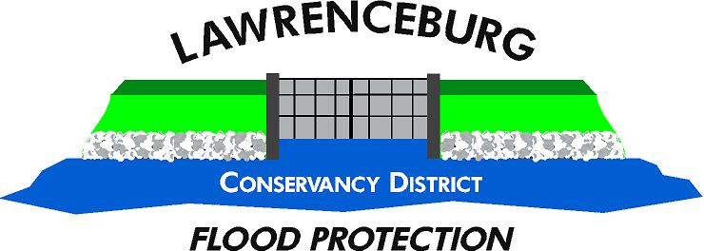

Permit Packet Instructions

Pick packet up at LCD’s offices: 225 East Eads Parkway
Or Packet can be requested by email from Business@LCDLevee.com, however the permit must be received from LCD before signing.

The packet contains
- Flood Control Permit – valid after all parties have signed and initialed
- Lawrenceburg Levee Accreditation Projects – informational sheet regarding Provisional Accreditation and FEMA Levee Mapping Updates
- Lawrenceburg Flood Control Permit Agreement – to be signed by all parties

Your project plans will be reviewed by our professional engineers at their current rate. Being efficient with plan submissions, by submitting what you hope to be complete plans, may help keep your costs down.
It is the responsibility of the Owner and their Developer, Engineer and other agents to research all information relevant to the project, including, but not limited to, the LCD Ordinance and Developer Checklist found on our website LCDLevee.com, 44 CFR 65.10 requirements, FEMA LAMP, etc.
The LCD welcomes any questions regarding this process and can meet to discuss, as needed.

Paul Seymour, Superintendent
812-584-8820
LCDPaul44@gmail.com

